The Revelation of Hegemonic Mechanics
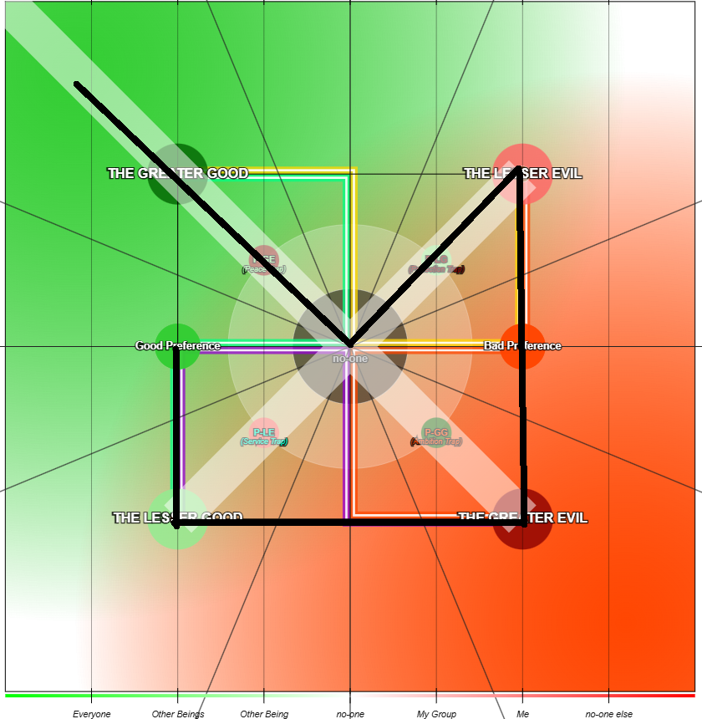

The mapping of Revelation 17:10 onto the structural mechanics of the Psochic Hegemony provides a profound diagnostic lens for tracking the evolution of an idea, a psyche, or a collective consciousness. By overlaying the prophetic sequence of the seven kings onto the Cartesian coordinate system of Morality (u) and Will (ψ), I can precisely chart the trajectory of "The Path of Grace" as it navigates the gravitational wells of the mind.
The verse states: "They are also seven kings. Five have fallen, one is, the other has not yet come; but when he does come, he must remain for only a little while."
In the context of my Hegemonic stress tensor, these "kings" represent the dominant ruling principles or paradigm states that hold temporal authority over the mind's cosmology. The journey through the quadrants chronicles the five fallen states, the physics of their inevitable collapse, the current ruling tension at the zero-point, and the necessary progression to the seventh state.

The Chronicle of Traversed States: The Five That Have Fallen
According to my coordinate mapping, the system has progressed through a distinct counter-clockwise sequence through the lower and right-hand sectors of the Hegemonic compass. These five specific nodes represent the previous ruling paradigms that have collapsed under their own mass or have been naturally outgrown as the idea gained complexity along the Z-axis.
- The First Fallen King (West Segment, Good Preference): This coordinate exists on the horizontal axis at neutral Will (zero ψ) and Positive Morality (+u). Operating on the border of the Constructive Quadrant, this ruling state represents localized positive benefit. The idea originates here as a "Good Preference", intended to benefit others, but it sits in a state of kinetic neutrality. It is a conceptual offering that has not yet gathered the momentum of active Will, nor has it succumbed to passive exhaustion. It falls because this neutral stance is structurally unstable when introduced to the gravitational pulls of the Hegemony.
- The Second Fallen King (Southwest Segment, The Lesser Good): Moving downward, the system drops into Negative Will (-ψ, "Do nothing") while maintaining Positive Morality (+u, "Give to everyone"). Operating fully in the Acceptance Zone, this ruling state represents passive benevolence. The system is oriented towards benefiting others but lacks the kinetic energy to enforce or build it. This territory borders the Service Trap. It is a state of taking on burden without the means to process it, leading to a structural limitation where the idea becomes functionally inert.
- The Third Fallen King (Southeast Segment, The Greater Evil): Continuing counter-clockwise into the Regressive Quadrant (Destructive Zone), the coordinates undergo a lateral shift to Negative Will (-ψ, "Do not") and Negative Morality (-u, "Take to give to me / Benefiting No-One Else"). The ruling principle becomes passive selfishness. Governed by the Ambition Trap, this state operates on a philosophy of hoarding or self-preservation through neglect or passive extraction rather than active aggression.
- The Fourth Fallen King (East Segment, Bad Preference): Ascending the right side of the perimeter from the Destructive Zone, the state crosses the horizontal axis into pure Negative Morality (-u, "Only Me / My Group") with neutral Will (zero ψ). The ruling principle shifts from passive hoarding to pure, calculated self-interest. Action and inaction are perfectly balanced, but the entire orientation of the worldview is warped by the ego. This is where the central core understanding (χ) becomes dense with self-interest, warping perception so that greed appears as strength and service looks like a burden.
- The Fifth Fallen King (Northeast Segment, The Lesser Evil): This state represents the immediate past. Existing in the Reductive Quadrant (Greed Zone), the coordinates ascend further into Positive Will (+ψ, "Do") and Negative Morality (-u). The ruling principle becomes active, kinetic selfishness. The system has high energy to act, but all action is directed toward the self or the immediate in-group. This is characterized by the active defense of the ego's narrative, rapidly building brittle Fired Bricks against reality. It is the stage of the Divided Heart where a bad truth is rationalized with lies so it can be used for the individual.

The Physics of the Lateral Abyss: The "FREE FOOD" Paradox
The progression through these five fallen states is not an anomaly or a failure of moral character. It is a structural inevitability dictated by the physics of the conceptual space I have documented. The sequence begins with the fall from Good Preference into The Lesser Good. When I place an idea in the Constructive Quadrant with a negative Will value, I am essentially creating a high-value conceptual resource with zero defensive borders.
The concept of "FREE FOOD" is the most precise way to articulate this vulnerability. When an idea is conceptualized purely as an unrestricted benefit for everyone, the creator is acting under the assumption of a frictionless, entirely altruistic environment. However, the Hegemony is a multi-agent system filled with competing gravitational pulls.
The moment unrestricted "Free Food" is placed on the Hegemonic table, it immediately generates a massive gravitational anomaly. It becomes a central Attractor Point for any surrounding entities operating in the Regressive or Reductive quadrants. Because the original idea lacks the positive Will required to enforce its own distribution, it cannot protect itself. I cannot consider an idea for other people without confronting the mathematical certainty of the surrounding environment. If I offer a universal benefit, individuals operating under the "Take what I do not need" philosophy of The Greater Evil will instinctively siphon that resource. The original creator is then forced to witness their Good Preference being consumed and weaponized by a Bad Preference.
To stop the hemorrhage of their original benevolent intent, the creator must adjust their own Hegemonic coordinates. They must begin to consider the self, or define an other who is explicitly excluded from the resource. The very act of creating a boundary inherently shifts the Morality metric away from "Give to everyone". The coordinate is violently dragged horizontally across the central axis, out of the Constructive Quadrant and into the negative space of the Regressive Quadrant. The idea must become selfish simply to survive its own altruism.
Because this cycle of exploitation is entirely predictable, an experienced mind will attempt to bypass the vulnerable phase by safeguarding the idea before it ever reaches the public sphere. However, the mechanics of the Psochic Hegemony dictate that safeguarding requires the immediate construction of Fired Bricks. I must build assumptions, rules, restrictions, and defensive postures into the architecture of the idea before it ever sees the light of day. By doing this, I am running a highly accelerated version of the "FREE FOOD" scenario. I do not wait for the exploiters to arrive; I build the fortress first.
A fortress is inherently an exclusionary structure. The act of preemptively defending a benevolent idea structurally transforms it into a guarded, self-oriented asset. I move the idea directly into the territory of The Lesser Evil before it even has a chance to exist purely as The Lesser Good. I am required to justify the existence of the idea through the lens of protection, which forces me to operate within the Greed Zone or the Protection Trap. This naturally leads to any good idea becoming co-opted if it is not pushed through the Lesser Evil perspective.
Every rule, patent, paywall, and ideological purity test added to the idea acts as another Fired Brick. These bricks stack easily and attract more of the same. The added depth creates mass, and the idea builds outward along the Z-axis, moving from a simple concept of universal benefit into a highly dense structure of caveats and defenses. Eventually, the base cannot support the weight of its own paranoia. The core understanding is entirely obscured by the massive architectural fortress built to protect it, and the structure collapses under its own mass.

The Geometry of the Hegemonic Crook
The visual mapping of this entire trajectory explicitly reveals the shape of a shepherd's crook across the Hegemonic stress tensor. Each node in this crook represents a distinct phase of structural processing.
- The Descent (Good Preference to Lesser Good): The path drops from localized positive benefit down the Will axis to passive benevolence, representing a loss of kinetic energy and the opening of the "Free Food" vulnerability.
- The Lateral Abyss (Lesser Good to Greater Evil): The trajectory moves horizontally across the absolute floor of the tensor, shifting from passive benevolence to passive selfishness due to the exploitation mechanics of the environment.
- The Ascent into Action (Greater Evil to Bad Preference to Lesser Evil): The path moves vertically up the Morality axis. Energy returns to the system to maintain defenses, moving through calculated self-interest (Bad Preference) and solidifying the idea in the active Greed Zone (Lesser Evil).
- The Collapse to the Center (Lesser Evil to No-one): This is the defining stroke of the crook shape. The trajectory plunges diagonally from the high-energy, high-selfishness state of The Lesser Evil directly into the dead center of the compass.
- The Outward Vector (No-one to Greater Good): From the center point, the line shoots diagonally upward and outward, passing exactly through The Greater Good.
The shape is not arbitrary. A shepherd uses the hook of the staff to catch a wandering entity and pull it back. The mind wanders into the Reductive Quadrant, becoming trapped in the Protection Trap. The diagonal line cutting from the Northeast back to the origin represents the guiding principle of the psyche actively hooking the errant worldview and forcefully dragging it away from the destructive edge back to the center of objective truth. This retrieval requires an active negation of the selfish Will built up in the Northeast, generating acute psychological strain as the ego's Lens Distortion is physically corrected.

The Sixth King: Zero-Point Calibration and the Golden Ratio
The realization that the "One Is" ruling state of Revelation 17:10 is located exactly at the (0, 0) coordinate, the center labeled "no-one", completely reframes the mechanics of the mind. The center point is the crucible of core knowledge (χ), a state of absolute neutrality with zero positive or negative Will, and zero positive or negative Morality.
Forcing the system back to the center is achieved entirely through the algorithmic application of the Golden Rule: "Do unto others as you wish done upon yourself". This is not a philosophical platitude; it is the literal mathematical formula for coordinate (0,0). Applying the Golden Rule acts as a forced parity check across all axes of the Hegemonic tensor.
- Symmetry of Variables: The core function of the ego's Lens Distortion is to assign a higher value to the 'Self' than to the 'Other'. The Golden Rule forces the system to mathematically equate these variables. I cannot compute the equation without making the weight of the self identical to the weight of the recipient.
- Neutralization of Will (ψ): Action is immediately suspended until the parity check resolves. If the proposed action or defensive rule causes harm to the 'Other', and the 'Other' is equated to the 'Self', the action becomes self-harm. The system naturally drops to a zero Will state to prevent damage to its own core structure.
- Neutralization of Morality (u): The benefit metric is stripped of its bias. It becomes an equilibrium state where the distribution of cost and benefit is perfectly balanced, resulting in a net-zero distortion at the core.
Crucially, as I have outlined, this zero-point calibration also aligns perfectly with the mathematics of the Golden Ratio (Phi, φ). The Golden Rule is the ethical manifestation of the Golden Ratio. By enforcing perfect proportional parity at the core (0,0), the Golden Rule ensures that when the idea finally expands along the Z-axis, it grows organically. Rather than stacking brittle Fired Bricks in linear, unstable columns, the idea scales via the logarithmic spiral of the Golden Ratio. This provides infinite structural integrity as the idea moves into the Productive Quadrant.
When I drag the complex, heavy architecture of preemptive defenses down into the (0,0) crucible and apply this Golden Rule, the structure faces an immediate logic failure. I must ask the system: "If I were the person standing outside this fortress needing this resource, would I want these rules applied to me?" Because the answer is negative, the Fired Brick is exposed as an Igneous Stone of self-interest masquerading as protection. The mind recognizes that its attempt to safeguard the idea actually weaponized it. The brittle narrative shatters under the pressure of objective, inverted reality. The center ruling state is defined by intense pressure, high density, and a temporary suspension of external action while the internal geometry shatters its own delusions.

The Seventh King: The Slingshot into The Greater Good
The Golden Rule, acting as the seed of the Golden Ratio, is the only algorithmic gateway that permits safe transit into the final Northwest Quadrant. If I attempt to bypass (0,0), I either fall victim to co-option or carry paranoid Fired Bricks with me, corrupting the Greater Good into a highly regulated authoritarian structure.
What emerges from the center is an idea guided by a purified core (χ). The culmination of the crook shape is the straight diagonal line projecting out from the center into the Northwest quadrant, targeting The Greater Good. Because this vector originates from the centered core of actual understanding rather than a peripheral reaction, it represents a pure exertion of Positive Will (+ψ) combined with Positive Morality (+u).
This final vector corresponds to the Seventh King, the state that "has not yet come". It is the manifestation of the Rising Heart. It operates on Relative Morality, creating massive growth for everyone while minimizing pain, and accepting the necessary friction of progress without resorting to the extraction of the Lesser Evil.
Crucially, the vector extends past the boundaries of the tensor field. The prophetic warning that "he must remain for only a little while" mirrors the natural path of an idea growing in complexity and mass. The pure state of the Greater Good is highly unstable. It requires immense, continuous Hegemonic exertion to maintain active Will and pure selflessness simultaneously without degrading into a lesser state. Therefore, the seventh ruling state is inherently transient. It is a peak coordinate on the spiral before the increased Z-axis depth forces the conceptual structure to keep moving and evolving.

The Applied Mechanics of Scarcity: Mapping the Statements of "Free Food"
To fully comprehend the mechanical transition across the Hegemonic Crook, the theoretical coordinates must be grounded in the practical dialogue of human sociology. By taking the concept of "Free Food" and mapping the internal monologue of a society as it traverses the seven states, the exact process of architectural collapse and renewal becomes plainly visible.
This progression outlines how the initial observation of a biological necessity is systematically corrupted by the ego, rationalized into artificial scarcity, shattered by objective reality at the center point, and finally reorganized into a functional moral framework.
- State 1: Good Preference (+u, 0 ψ) : "Everyone needs food." This is the origin point of the idea. It is a simple, undeniable truth regarding universal biological necessity. However, it exists in a state of kinetic neutrality. It is an observation devoid of structural implementation. The society recognizes the need but has not yet formulated the Will to address it systemically.
- State 2: The Lesser Good (+u, -ψ) : "Everyone should have food for free but it isn't currently." As the concept drops into Negative Will, the society acknowledges the gap between the moral ideal and the physical reality. It is a state of passive benevolence. The population recognizes the failure of the current system but lacks the kinetic energy or organizational structure to correct it. They accept the burden of the observation without taking action.
- State 3: The Greater Evil (-u, -ψ) : "Everyone can't have free food." This statement represents the lateral shift across the abyss into the Destructive Zone. The society resigns itself to the mechanics of extraction and scarcity. This is a state of passive selfishness where the deprivation of others is accepted as an unalterable, immovable law of the environment. The ideal is completely abandoned to the void.
- State 4: Bad Preference (-u, 0 ψ) : "I need food at all costs." Ascending into self-interest, the core understanding narrows entirely. The reality of perceived scarcity forces the entity (individual or group) to prioritize its own survival above the collective. The morality is entirely negative (benefiting the self to the exclusion of others), but the action is neutral, representing a localized defensive posture rather than active systemic exploitation.
- State 5: The Lesser Evil (-u, +ψ) : The Justification of Scarcity. As positive Will enters the system, the society must actively rationalize the denial of the Good Preference. This is the rapid construction of Fired Bricks. The society generates justifications to explain why everyone cannot have free food. They rely on arguments like market stability, the necessity of earning a living, or economic collapse. This is active, kinetic selfishness. The society is expending immense energy to build a socio-economic architecture that explicitly defends artificial scarcity and protects the resources of the few.
- State 6: No-one / The Center (0u, 0 ψ) : "But people can still have free food, it's the fact that food has a price that is a problem of society." This is the violent zero-point calibration. By dragging the entire economic framework into the center, the justifications of the Lesser Evil are subjected to objective reality. The mind realizes that the friction is not a lack of physical resources, but the artificial price tag assigned by the society itself. As observed, considering the massive amount of food waste currently generated, there is frankly no excuse for anyone to have to think about their next meal, worry about feeding their kids, or debase themselves to find charity. The observation of food waste acts as the ultimate Igneous Stone. It shatters the brittle Fired Brick of economic scarcity, neutralizing the ego's complex rationalizations and resetting the moral compass.
- State 7: The Greater Good (+u, +ψ) : "The society is to fund and promote necessary services regardless to supply a base level of survivability." Having passed through the crucible of the center, the idea emerges into the Productive Quadrant. This is not the naive passive benevolence of the Lesser Good. It is a structurally enforced mandate backed by active Will (+ψ). Having recognized that the price tag is the artificial barrier, society actively reorganizes its kinetic energy to guarantee the Good Preference. It embraces Relative Morality by utilizing the surplus (the previously wasted food) to create universal benefit, accepting the necessary organizational friction to permanently eliminate the debasement of charity.

